Parenthesis: The importance of creating memories with your children

Source: Akhila Das Blah, Educational Consultant& Content Writer

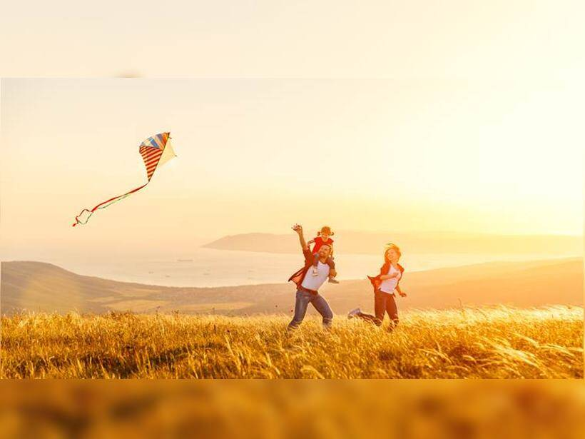
If you were to close your eyes and cast your mind back to your childhood and think of what made you happy, what would you remember? The smell of mom’s cooking as she made your favourite foods, the joy of running around with the neighbourhood kids, going for a Sunday treat of ice cream with your dad, waiting to go to the lending library to exchange books or waiting eagerly for your cousins to arrive so you can spend yet another crazy, fun-filled vacation with them. On our birthdays, we remember the games we played or the friends we played we are.

How many of us actually remember what gifts we got for each birthday? Or what toys we played with or what toys our friends had? If one were to really think about it, what we remember is not the material objects but the feelings or emotions connected with them. We remember the experience of playing with someone and the feeling it created within us.
Unfortunately, the kind of hectic schedules that we have today coupled with increased disposable income leads us to buy more material possessions for our children and spend less time on experiences. But these experiences are what create long-lasting memories and it is the feeling captured through these experiences that remain in our hearts and minds.
So, how can we create experiences for our children in order to build long-lasting memories? Memories that will make them look back at their childhood with fondness. Experiences that they will associate with feelings of belonging, joy and happiness. The obvious answer would be to take holidays together. Travelling allows for a range of experiences, it allows us time off from our daily, mundane routines to spend time together. It develops our personality as we explore new cultures and cuisines. It builds character as we learn to deal with lost luggage, flights being overbooked and other such adventures that we find ourselves in. But, even if we end up stranded in a hotel room for the whole weekend because we are caught in a thunderstorm, we will remember the fun we had playing board games and ordering room service. In any case, a memory will have been created. Sometimes, it’s the worst vacations that create the best memories.
But the truth is that life isn’t a permanent vacation. And, certainly, not all of us have the liberty of scheduling multiple vacations throughout the year in order to create lasting memories. So, do we wait for our next vacation or can we create some experiences in our daily lives that allow us to make those childhood memories for our children?
Tara, a parent of a two-year-old, says that she has been singing the ‘Gayatri Mantra’ to her son Kabir as part of his bedtime routine since the day he was born. She remembers her grandmother singing it to her in her childhood and she hopes that she can create a similar memory for Kabir as the years go by.
My husband takes our boys out for a Sunday treat every week. It’s his time alone with them. They get to choose the type of treats they want and spend that time talking about their school, friends and things that interest them.When we make experiences a part of our daily routine, we ensure that we create memories and moments that bring us closer to our loved ones. So, don’t wait for the next vacation. Think of a childhood memory that you would like to recreate with your child or come up with a completely new one of your own.

Take Sunday morning walks together. Or, if you like to drive, take the family for a picnic to a nearby picnic spot. If you enjoy cooking, get the children to help you make a meal every Sunday. Make Friday nights movie and popcorn night. Develop a secret handshake that only you and your kids know. Take your child once a month to her favourite restaurant for some one-on-one time with you. Leave notes in their lunchboxes for them to find. Stick post-its around the house reminding them how much you love them. Whatever you choose to do, you can be sure that your child will look back on these moments with as much fondness as you do on your childhood memories.

